VSCode Tutorial

VSCode Homepage
https://code.visualstudio.com/docs/python/python-tutorial

Python homepage
This is bible of python language, in case of any problem/download always refer to this website(don’t be afraid of the same)
https://www.python.org/

Code refactoring
Refactoring is the process of restructuring code, while not changing its original functionality. The goal of refactoring is to improve internal code by making many small changes without altering the code's external behaviour.

Getting started with VSCode
Prerequisites
To successfully complete this tutorial, you need to first setup your Python development environment. Specifically, this tutorial requires:
- Python 3
- VS Code
- VS Code Python extension (For additional details on installing extensions, see Extension Marketplace)

Python project infrastructure in VScode
Here Model_validation is the root directory/project directory. You should open this folder in VScode. However it should be noted that .venv contains things required to run Python, such as:
.venv/
├── Scripts/
├── Lib/
├── Include/
└── ...
So .venv contains: Python interpreter + installed Python packages and it doesn’t contain files such as historical_pnl.csv, market_data.csv, portfolio.csv, VaR results, Monte Carlo results, Excel reports and large logs (these files might be large in size)
The main reason for keeping large files out of .venv isn't specifically that .venv itself makes VS Code slow. The bigger concern is that you don't want VS Code's:
- Explorer,
- Search
- indexing
- Git
- language server
to unnecessarily scan huge datasets.So ideally you can also tell VS Code to exclude large directories/files from searching and watching.
Also, if this folder is git tracked, then you must see .git folder in the root directory.

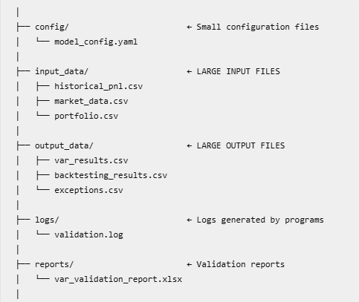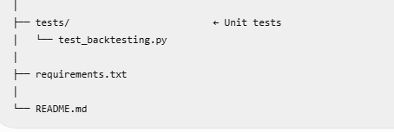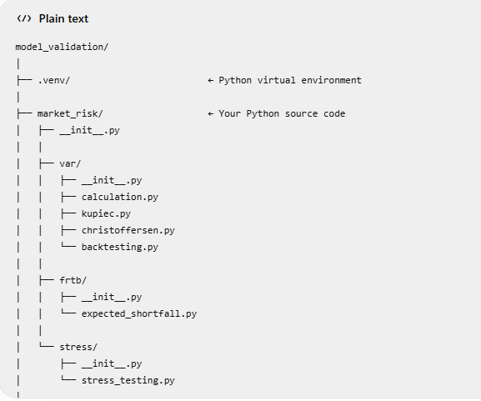

Python –m module
Since you use VS Code, understanding python -m is particularly useful because it helps you avoid one of the most common Python problems: installing a package into one Python environment but running your code with another.
python -m pip install numpy
│ │ │ │ │
│ │ │ │ └── package to install
│ │ │ └────────────── pip command
│ │ └──────────────────────── Python module to execute
│ └─────────────────────────────── "run this module"(m stands for module)
└──────────────────────────────────────── Python interpreter (your active interpreter in VSCode)
Basically it says : ask your python interpreter to find ‘pip’ module and run this module to install numpy package.
The problem is that you might have multiple Python installations/environments.(python 3.11, python 3.12 and python 3.14) so <pip install numpy> doesn't make it as obvious which Python interpreter's environment you're installing into
Suppose your pip points to ‘C:\Python313\Scripts\pip.exe’ through system environment variables and your python points to ‘C:\Projects\MarketRisk\.venv\Scripts\python.exe’ then <pip install numpy> will install the package into ‘C:\Python313\’

Very important: -m is NOT specific to pip

<python -m X> Use this Python interpreter to execute module X.
< python -m http.server> Run Python's simple HTTP server.
< python -m unittest> Run the unittest module.
<python -m venv .venv> Run the venv module to create a virtual environment.

PATH variable setting change in VSCode

When you activate a virtual environment, the PATH environment variable for that terminal session is modified.
Suppose your system has: PATH
↓
C:\Python313\
C:\Windows\System32\
...

So when you type: python, your OS finds: C:\Python313\python.exe

After activating .venv, VS Code modifies the terminal's PATH approximately like this:
PATH
↓
C:\Projects\MarketRisk\.venv\Scripts\
C:\Python313\
C:\Windows\System32\
...

Notice that .venv\Scripts is now at the beginning.
Therefore: python finds ‘C:\Projects\MarketRisk\.venv\Scripts\python.exe’ and pip finds ‘C:\Projects\MarketRisk\.venv\Scripts\pip.exe’

And importantly, activation does not modify your Windows/system PATH permanently. The change is normally for that particular terminal session. When you close the terminal, that environment change disappears.

Python command | Meaning | Example | Explanation
python test.py | Run a Python file | python backtesting.py | Executes a specific Python script directly.
python -m test | Run a Python module | python -m pip | Finds and executes a module using Python's module search mechanism.
python -m package.test | Run a module inside a package | python -m market_risk.var.backtesting | Executes the backtesting module inside the var package, which is inside the market_risk package.
python -m package | Run a package | python -m market_risk | Executes the package's __main__.py file. The package must contain this file.

Python 3 installation

Python 3 is installed here, also in same folder you can see location of Anaconda-3, there are shortcuts. You need to right click on exe file to see actual file location
C:\Users\Prasoon Gupta\AppData\Roaming\Microsoft\Windows\Start Menu\Programs
Python - C:\Users\Prasoon Gupta\AppData\Local\Programs\Python
Anaconda – C:\Admin\C Drive\anaconda3

Normally I use Python system interpreter 3.11 in this case and not conda environment interpreter
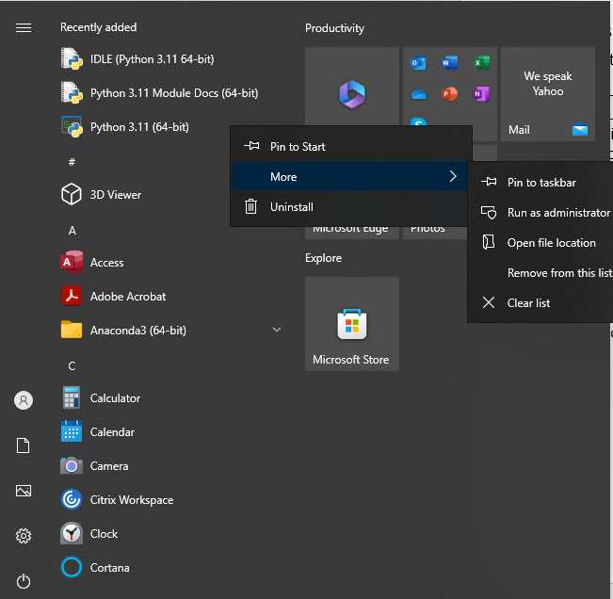

If this error comes then you need to add python exe path in Path environment variable as shown below
Python311\python.exe- I doubt this is not required
Python311\Scripts

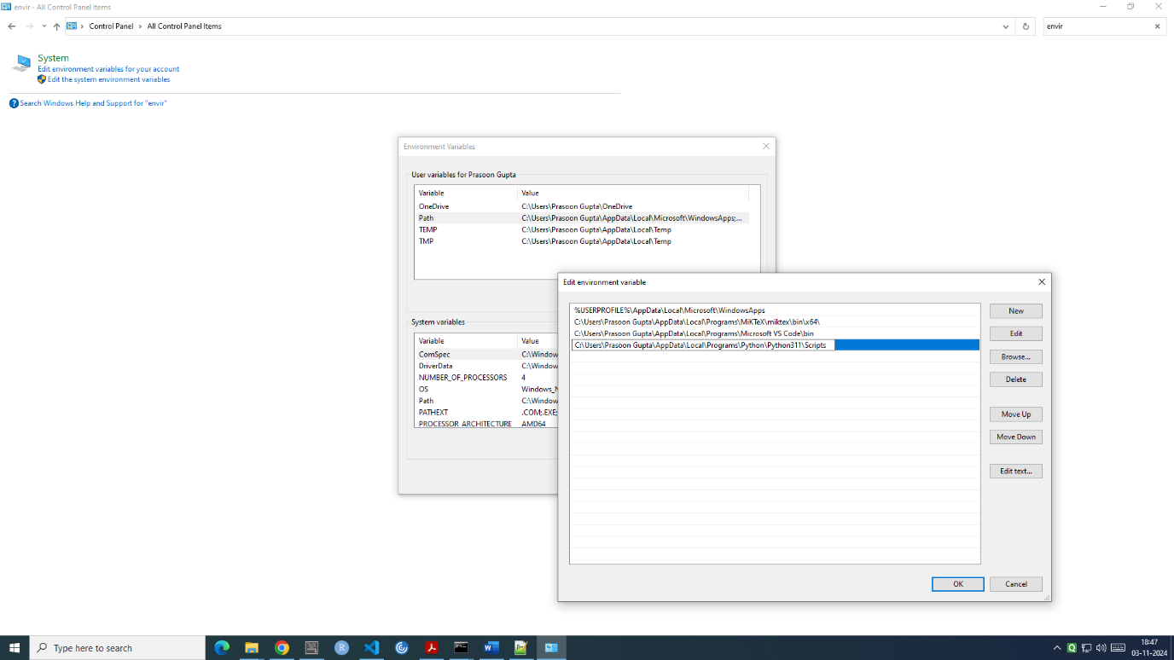

Start VS Code in a workspace folder

By starting VS Code in a folder, that folder becomes your "workspace".
.vscode is a folder which contains vscode workspace settings as well as configurations.

Create a virtual environment and check current interpreter
A best practice among Python developers is to use a project-specific virtual environment. Once you activate that environment, any packages you then install are isolated from other environments, including the global interpreter environment, reducing many complications that can arise from conflicting package versions. You can create non-global environments in VS Code using Venv or Anaconda with Python: Create Environment.
Quite useful because even if any package is upgraded, it is possible that your project is not compatible with the same, so with virtual environment you can keep packages with compatible versions.
Or simply use the commands
- If you want to create virtual environment name’.venv-py311’ using python 3.11 interpreter then <python -3.11 -m venv .venv-py311>
- If you want to create virtual environment name’.venv-py312’ using python 3.12 interpreter then <python -3.12 -m venv .venv-py312>

Is you want to switch between the two, first deactivate the current one i.e. just type ‘deactivate’ in PowerShell (PS) and then
- Press Ctrl + Shift + P.
- Type Python: Select Interpreter.
- You will see the available interpreters.
- Select the one you want.
Check your python version and current interpreter
<python --version> and <python –c “import sys; print(sys.executable)>
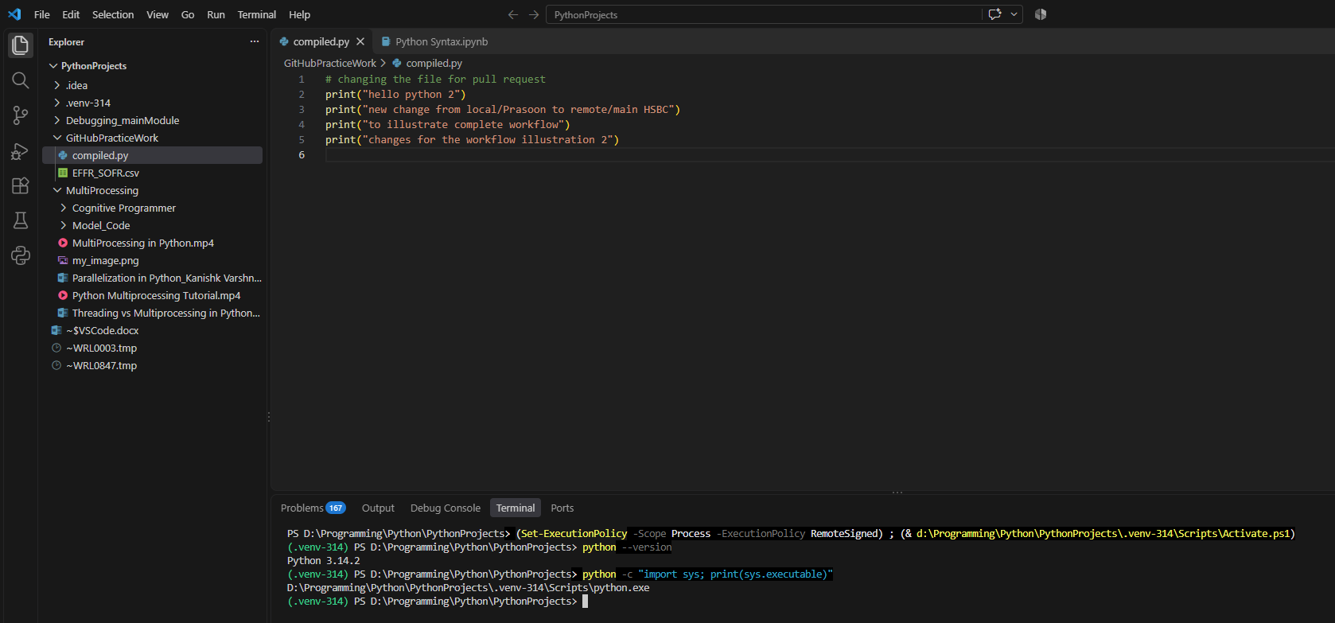Below are the details of virtual environment I am using in VSCode

Here you can see all packages available in virtual environment (Lib\site-packages)
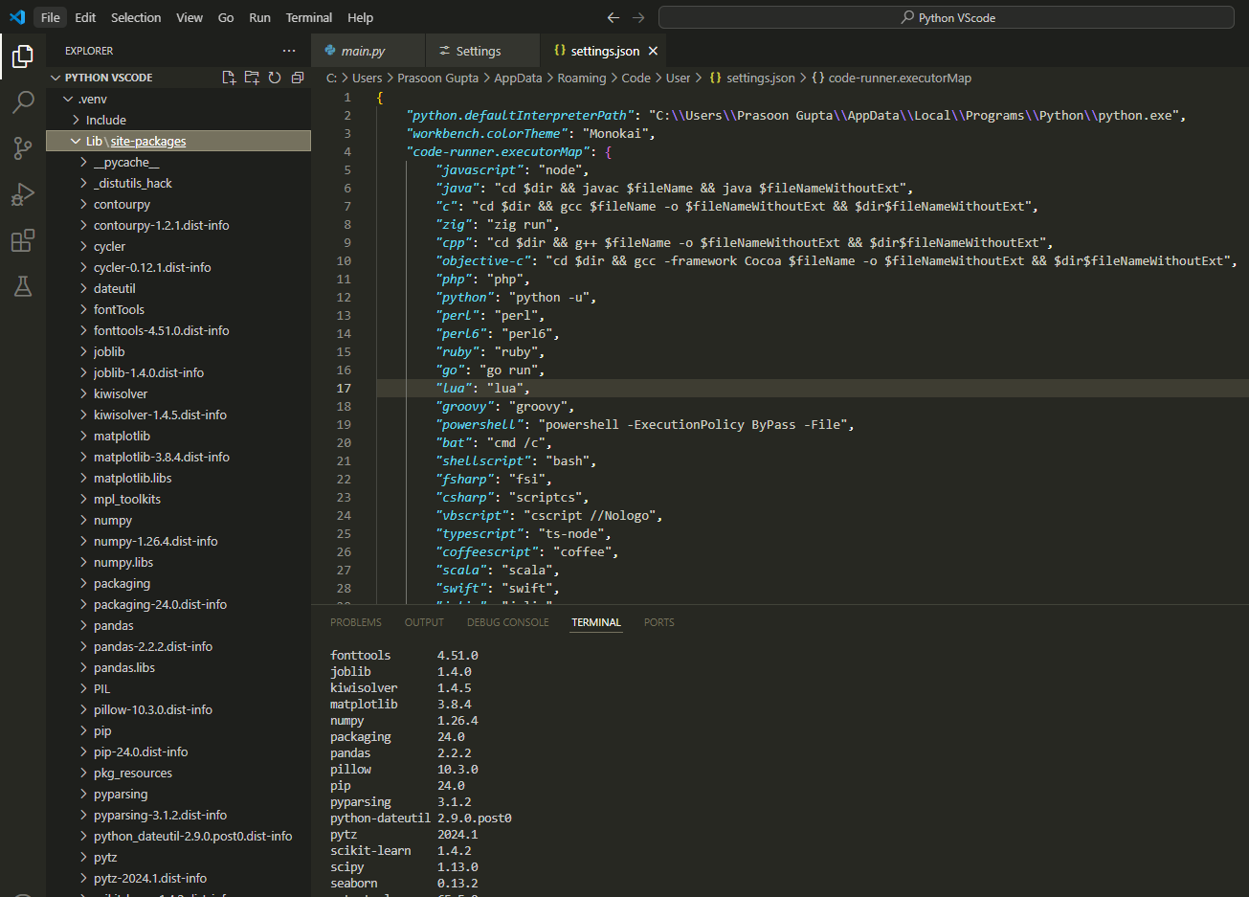
The Lib folder contains the Python libraries/packages installed inside this particular virtual environment. Whereas, Scripts folder is different. It contains the executables and command-line scripts associated with the virtual environment.
Open the Command Palette (Ctrl+Shift+P), start typing the Python: Create Environment command to search, and then select the command.

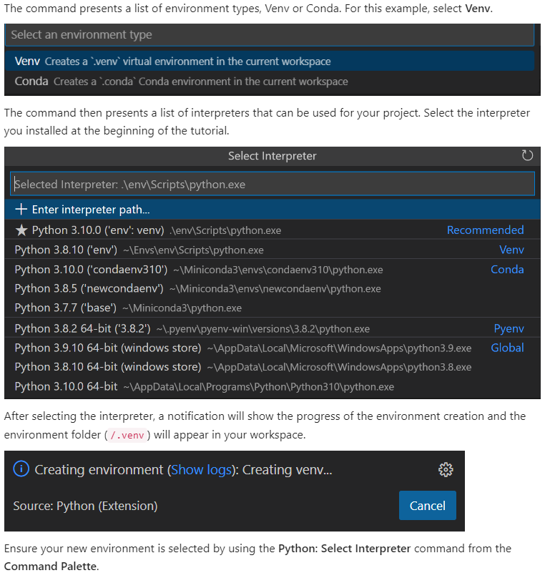The command presents a list of environment types, Venv or Conda. For this example, select Venv.

Any package that you install will be downloaded in ‘…\lib\site-packages’ directory.

And python exe is stored under ‘…\Scripts’ directory.

Extensions
Extension is used to install additional functionalities of the same for ex, good to install python which gives us additional functionalities. Below is the list of all bare minimum extensions
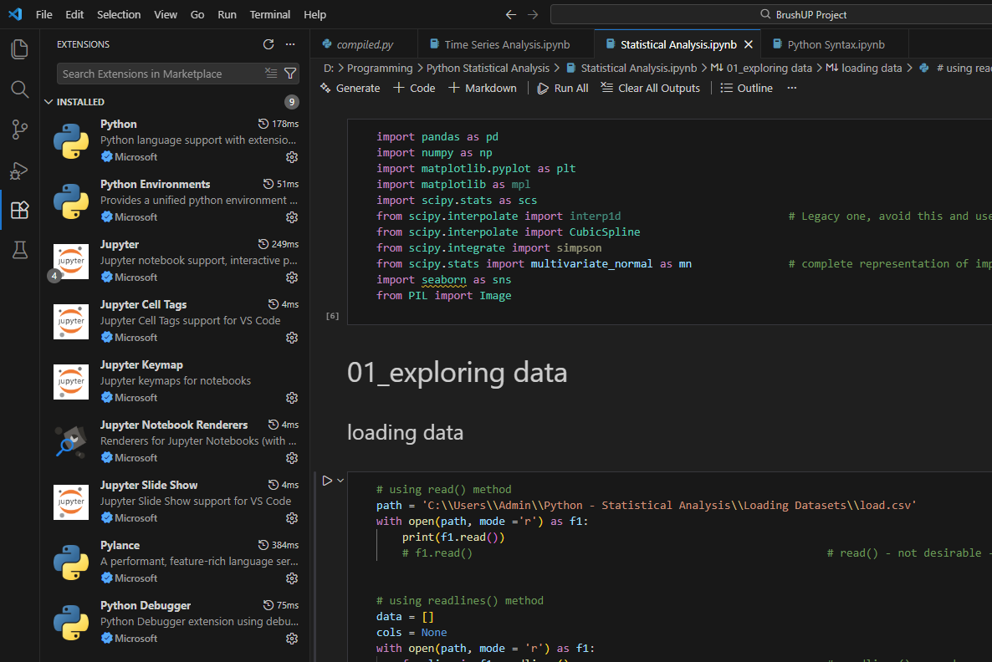

If you want to see settings of this extension, there are 2 options
- Either search this in extension and click on Extension Settings, then open JSON file
- Or go to settings of VSCode settings and search code runner and then click on Executor Map

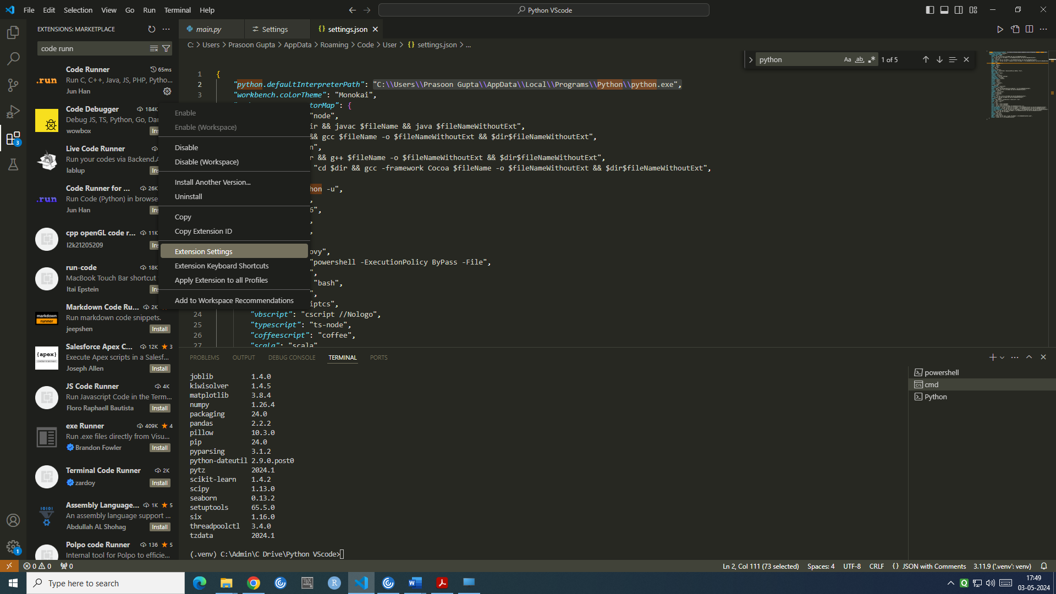

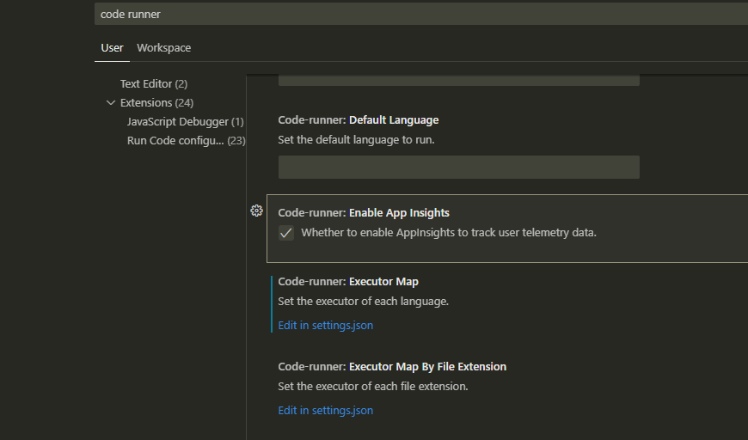
Note that by default it takes global python interpreter which you need to change to Virtual environment interpreter(Script – python.exe right click and copy path)

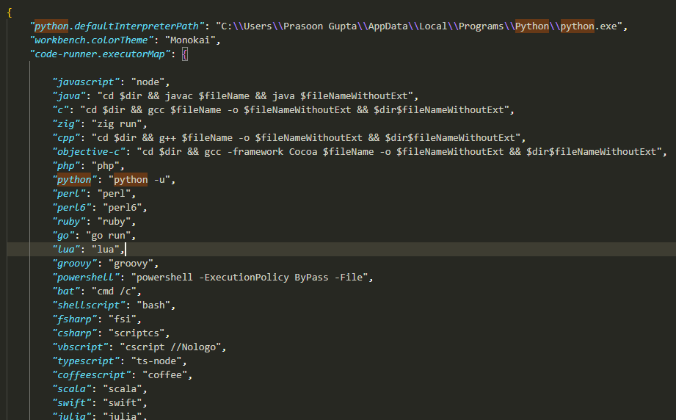

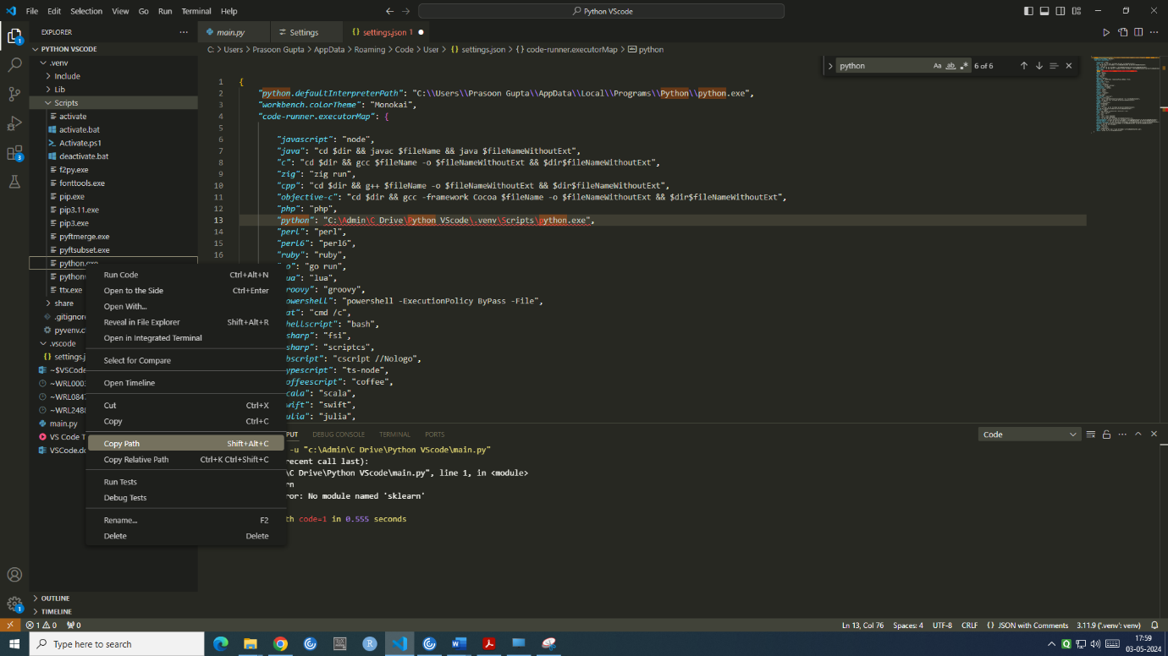

Settings Change

Go to manage -- settings --, here you see 2 types of settings – ‘user’ and ‘workspace’.
- User settings means for all the projects of VSCode means that whenever you open any folder/project in VSCode, these settings will apply
- Workspace settings means only for this project

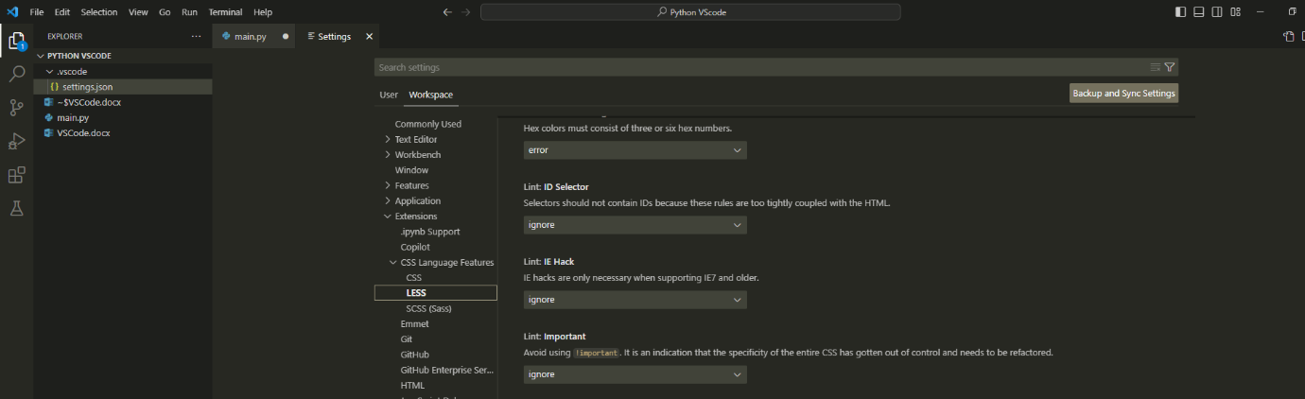
you can also click on JSON file to view these settings.

Side by side comparison
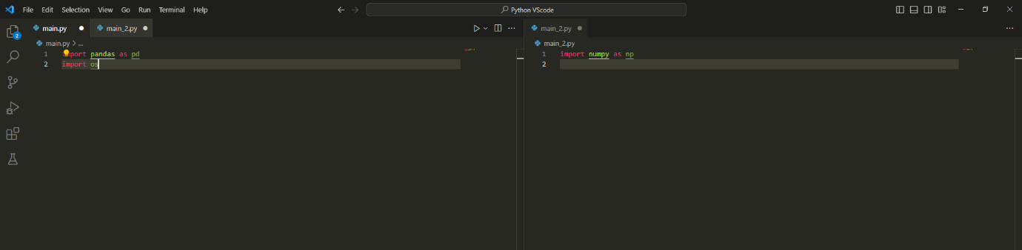On clicking below button, will allow to split screens which can be useful in side by side comparision

To install a new package
- To open a new terminal and type py -m pip install scikit-learn or pip install sklearn
- If you want to install with a version pip install pandas==1.3
- To see installed packages for python interpreter type pip list
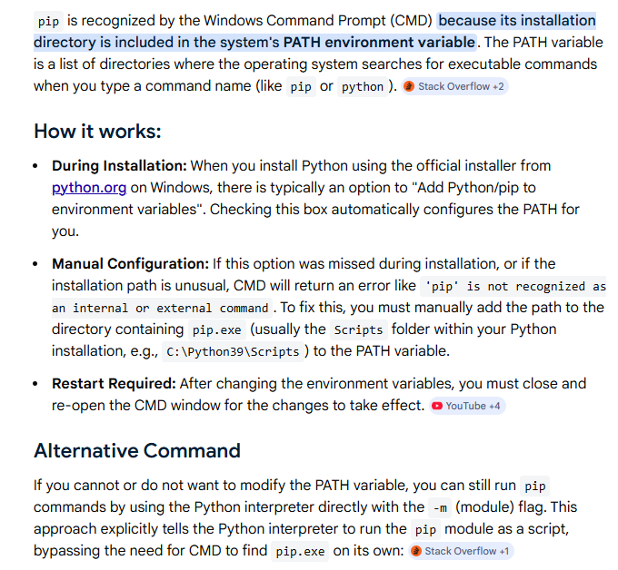

Keyboard shortcuts
You can see keyboard shortcuts, these are default ones. If you want to modify any of these then you double click on Keybinding and update it
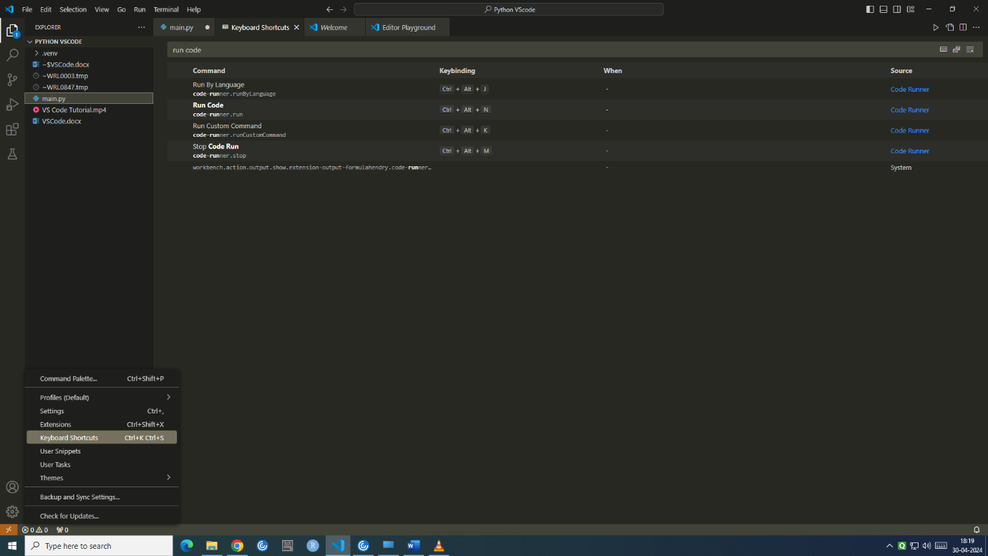

To execute a file
There are multiple ways to execute a python script
- Terminal(PowerShell or cmd/command prompt) – python main.py
- Debug Console
- Output

What Are PowerShell and cmd?
To understand PowerShell and cmd better, we must first define one term: command-line interpreter.
We perform many daily tasks on our computers, from opening video files to browsing the Web or even coding. But is there a way for us to communicate directly with the OS? Yes. A command-line interpreter is a mediator between humans and the OS of a system. It turns human-written text into understandable instructions for the OS. We call these translated instructions OS calls. The OS understands and operates these calls. Every Operating System has a built-in command-line interpreter; the built-in interpreter for Windows systems is the Windows command prompt, commonly called cmd.
There are many ways to execute a python programme in vscode,
- python xxx.py (execute this file)
- python -m module (The difference is not primarily which interpreter is used. The difference is how Python executes your code, in this case, it says that find the module market_risk.main using Python's module/package system and execute it)
- by using the run button (VS Code uses the Python interpreter selected for the workspace/file)

All three can execute Python using an interpreter, but the way that interpreter is selected and the way Python treats your code are different.
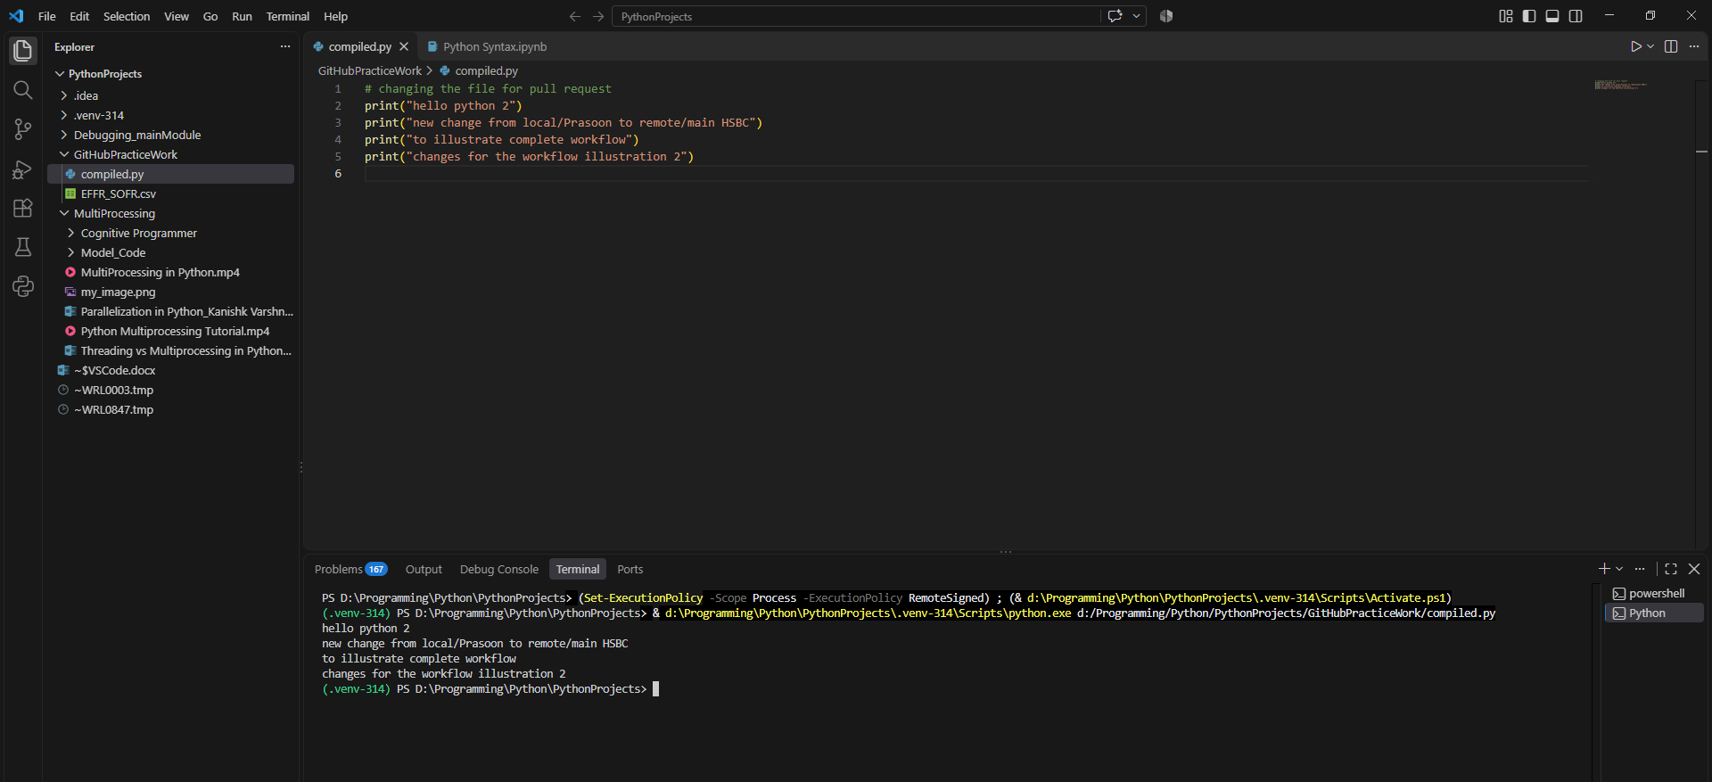
In the above Power Shell you see 3 paths
- (.venv-314) PS D:\Programming\Python\PythonProjects> we are in ‘.venv-314’ virtual environment and CWD
- d:\Programming\Python\PythonProjects\.venv-314\Scripts\python.exe : python interpreter
- d:/Programming/Python/PythonProjects/GitHubPracticeWork/compiled.py : python file

The Output panel displays internal messages from VS Code and its extensions, such as:
- Python extension logs (from Python extension for Visual Studio Code)
- Debugger activity
- Linter (flake8, pylint) messages
- Git operations
- Build system logs
👉 It’s mainly used for debugging tools and environment issues, not your script output.

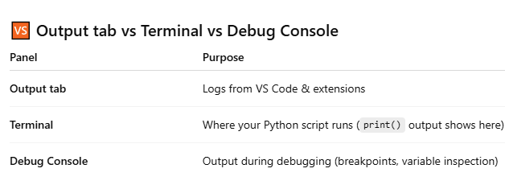

Debugging mode
Click on debug button on left panel and then click on ‘Run and Debug’. It will ask you to select which debugger you want to use ? if you have Python extension then select – debug current active file.
Or click F5

You can debug code in debug mode
- Watch
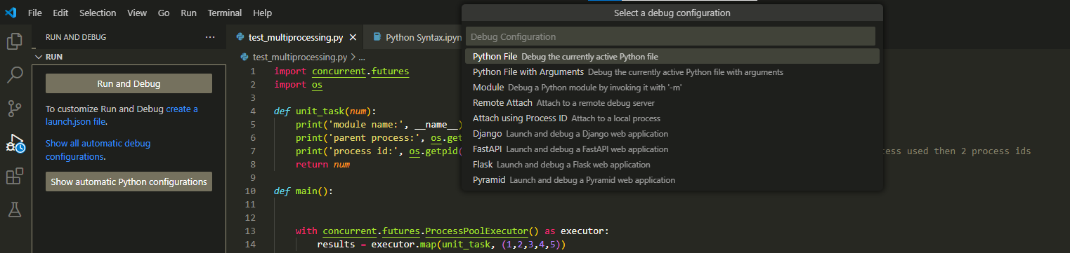
- Variables
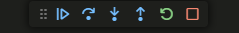

There are 3 different ways to enter breakpoint – Expression, Hit Count( code will stop when that line is hit # of times in code), Log Message ( can see this log message in ‘Debug Console’ everytime this line is executed – “ this is trade {self.trade_id}”
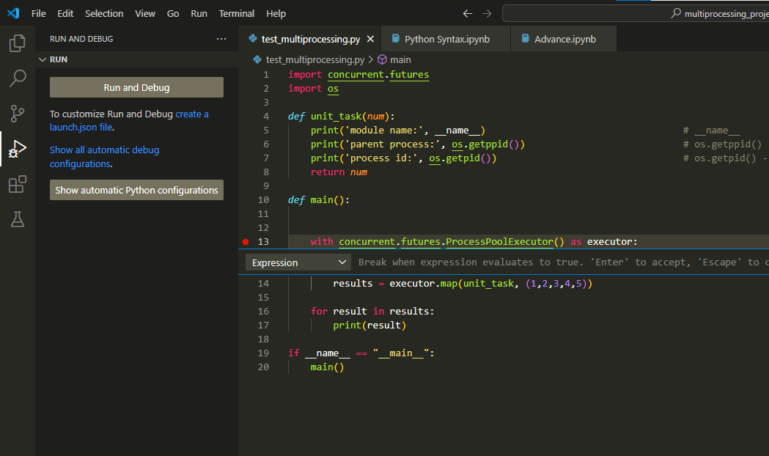

You can also put breakpoint on a function.
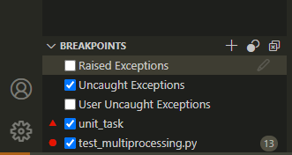

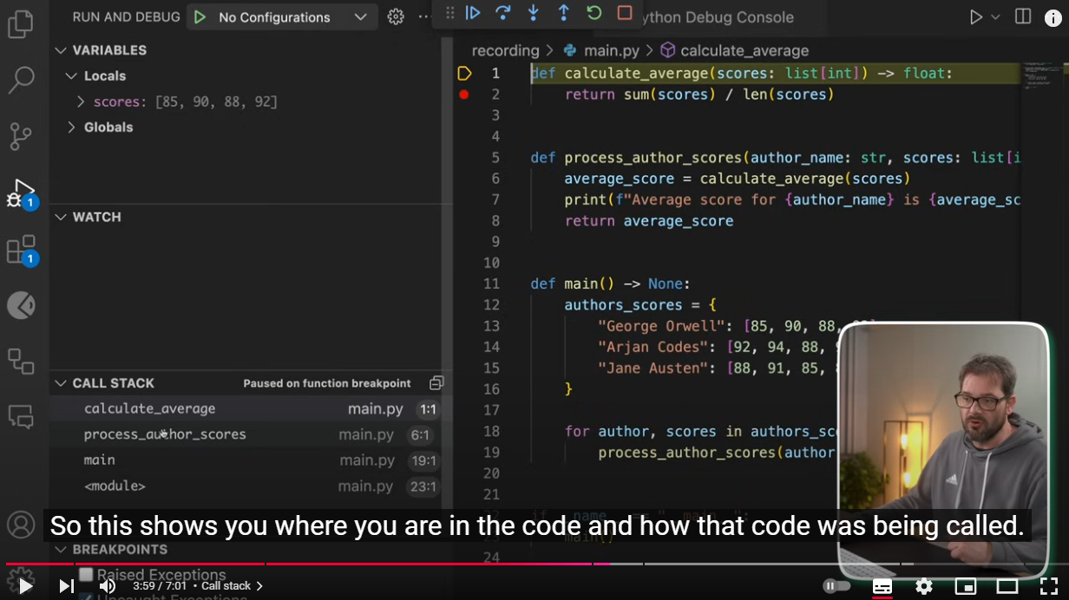
CALL STACK
This shows how functions are called – first main() process_author_scores() calculate_average()
And for each function, you can check locals and globals variables

These buttons are
- Continue from current break point and complete the code if no bug(lets say breakpoint at line 10 then complete till last line)
- Step over – go to next line
- Step into – step into current function
- Step out – step out of current function
- Restart – restart the code again(lets say breakpoint at line 10 then restart from line 1)
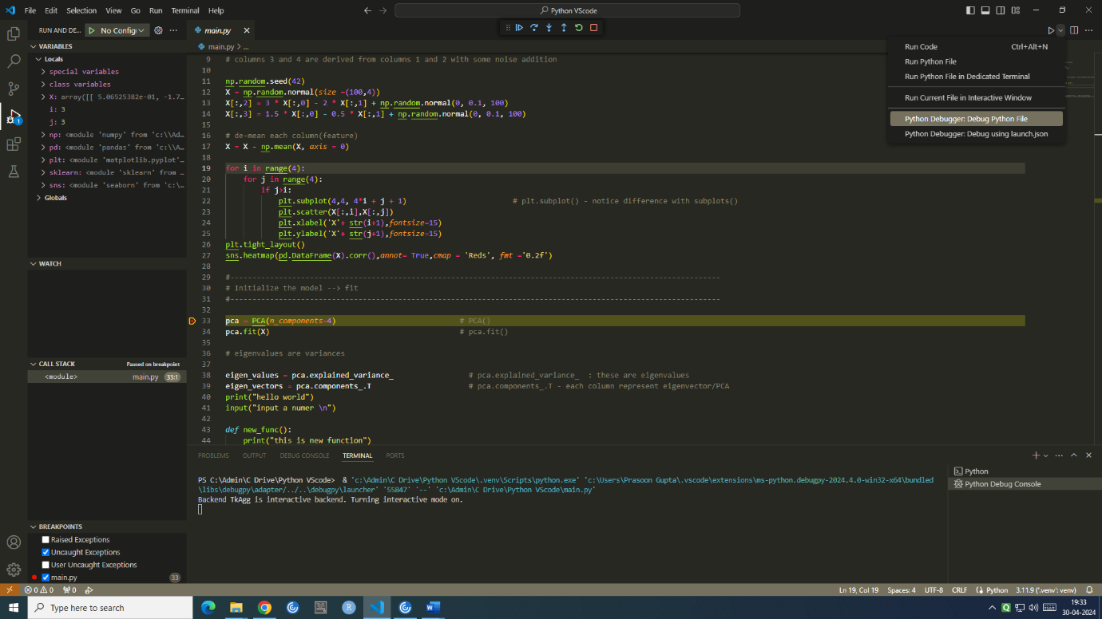
- Stop – stop the code(lets say breakpoint at line 10 then stop at that line)

Shortcuts
- Open the Command Palette (Ctrl+Shift+P)
- To open Terminal (Crtl + ‘)
- To take scrneeshot - Windows + Shift + S
- To kill terminal – Ctrl+Shift+C
- Comment/uncomment – Ctrl + /
- F5- to enter debug mode

  - Pycharm Tutorial
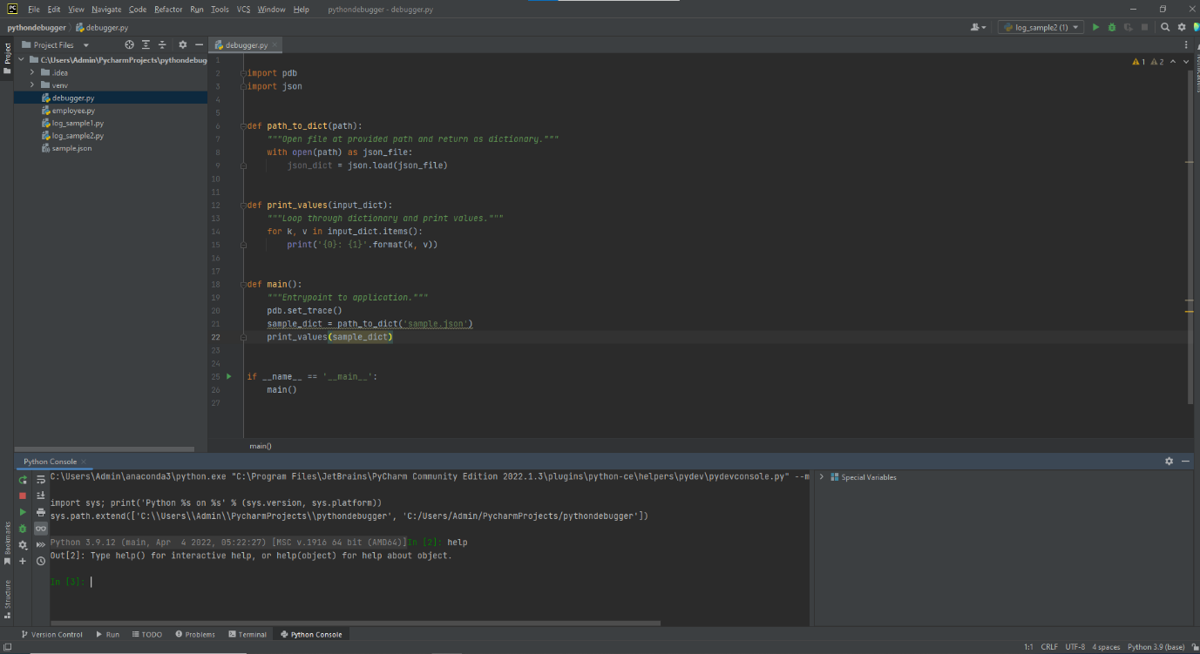

Create a new Project and Interpreter
First create a project, you can see the path if you hover mouse on it.
To set up interpreter and script path, select Edit Configuration and make changes, options available are:
- Anaconda python exe as interpreter- "C:\Users\Admin\anaconda3 \python.exe"
- prefer this one : System interpreter python3764python.exe (make it available for all projects)

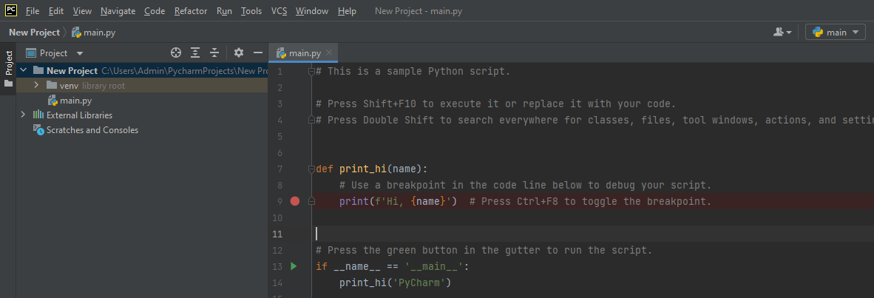

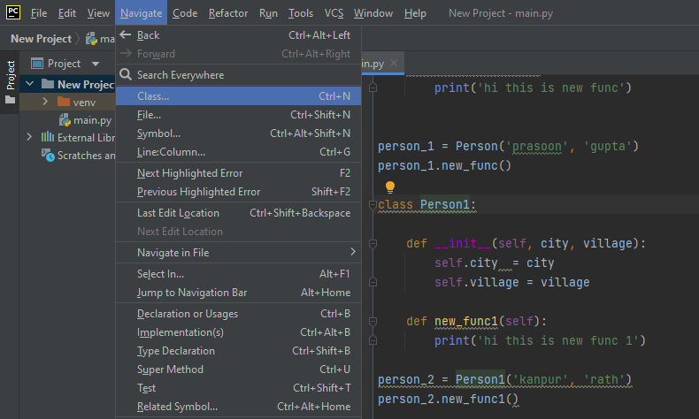
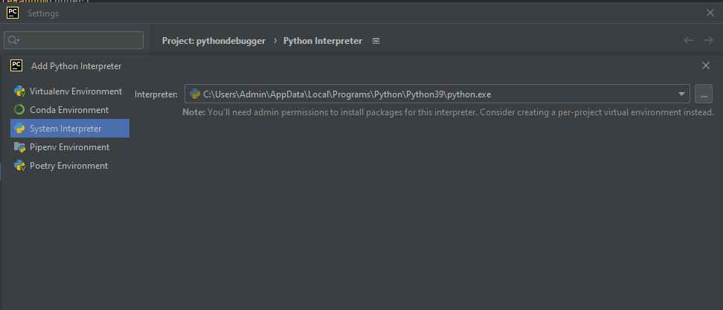

Useful tips in Pycharm

Using refactoring
rename a variable, you can change name of variable at all places in the project
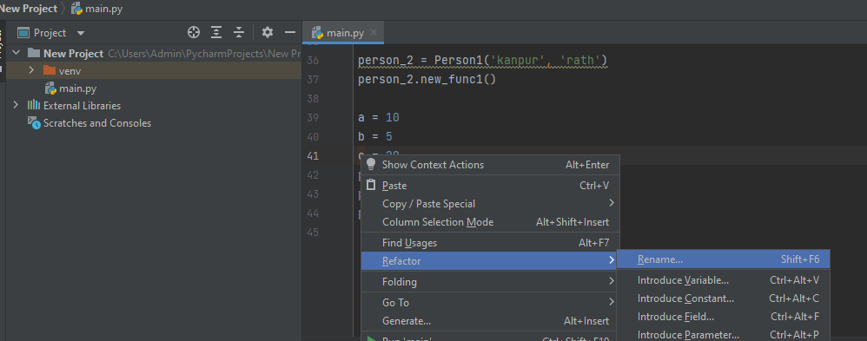

TODO – to prepare to do list in code (quite useful),
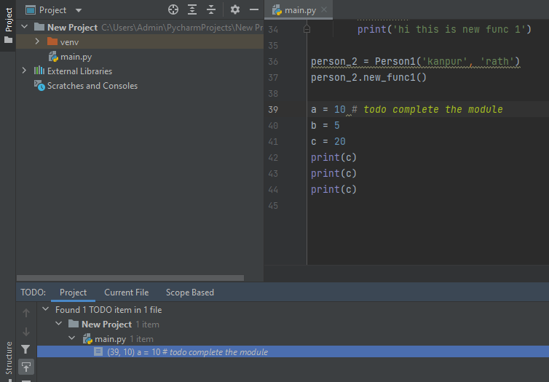

Search in Pycharm
Want to search keyword across all python files. Edit ---Find –Find in Files,
if want to search in same file then simply ctrl + F
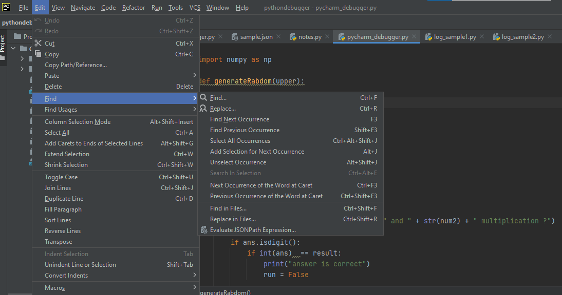

Logging levels
- DEBUG – detailed introduction, typically of interest only when diagnosing problem
- INFO – confirmation that things are working as expected
- WARNING – to indicate that something unexpected happened or indicating of some problem in near future – low disk space, software working fine
- ERROR – due to some problem, software not working fine
- CRITICAL – serious error, indicating that problem itself may be unable to continue running
Go to python documentation for more details about logging.basicConfig() - https://docs.python.org/3/library/logging.html
By default level is ‘WARNING’ so anything which is WARNING/ERROR/CRITICAL will be displayed in console/log file –define basicConfig() to override level.
Refer to scripts – log_sample1.py, log_sample2.py,employee.py
Videos - https://www.youtube.com/watch?v=-ARI4Cz-awo,
https://www.youtube.com/watch?v=jxmzY9soFXg

No need to reconnect to Console, right click and ‘clear all’

Debugging with Pycharm
- step over – this means move to nest line even if current line has method inside it. If there are breakpoint inside the skipped method, debugger will stop at them
- step into – step into a function, similar to s(tep)
- step into my code – similar to step into but will only skip into user defined function(I use it)
- step out – step out of current funtion, similar to r(eturn)
- run to cursor – explained below
- put a breakpoint for Pycharm debugger
- Evaluate expression and add watchpoint
When debugging, I frequently find myself in a loop, and I want to finish the loop and continue debugging that method. The only way to do that is to set a break point outside the loop, or position the cursor outside the loop and do "run until cursor”
Run to cursor basically means it will execute the code before the cursor point.
In debug mode, you can put breakpoint and once debugging done, you can either resume program/rerun debugger/stop debugger.
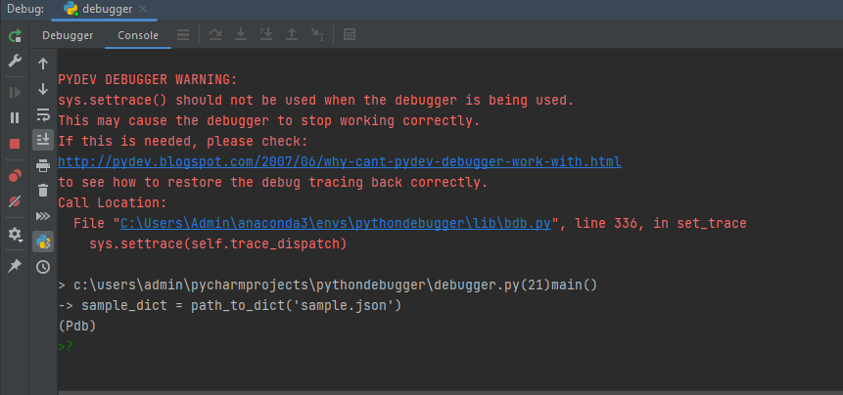

Refer to scripts – Pycharm_debugger.py
Videos - https://www.youtube.com/watch?v=sRGpvbhOhQs
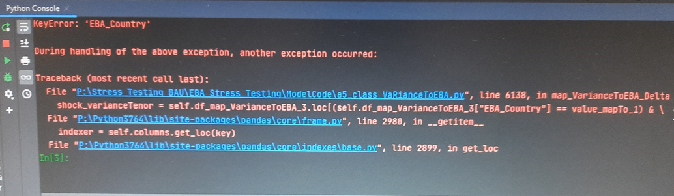
If you encounter any error in console, then click on that line and it will redirect you to the same line in code

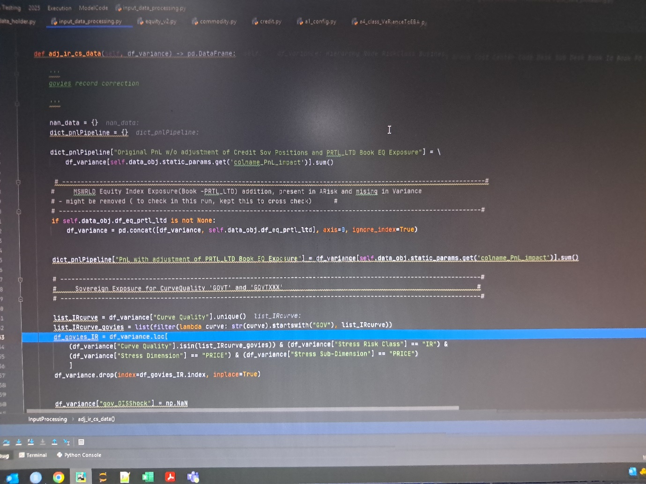
From line list_IRcurve_govies to df_goies, you need to select step over i.e. move to next statement/line. Normally I debug line by line so I use step into my code, but there lambda function is there so it will keep on executing the same line.step out will not work because it﻿ Steps out of the current method adj_ir_cs_data and takes you to the caller method(from where this adj_ir_cs_data has been called.

Special Variables window
check variables in variable explorer OR console (use tab for auto fill) – here emp1_email variable
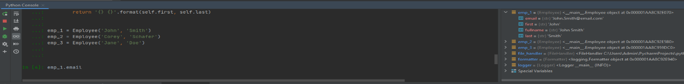

To set environment variable & execute python script in terminal –
Control Panel –- type env --- system (edit environment variables for your account)

Variable name variable value
py37 <python file name> C:\Users\Admin\anaconda3\python.exe

Now system will understand that when you type py37, it refers to python exe. To open terminal,
- Windows terminal
- Pycharm terminal

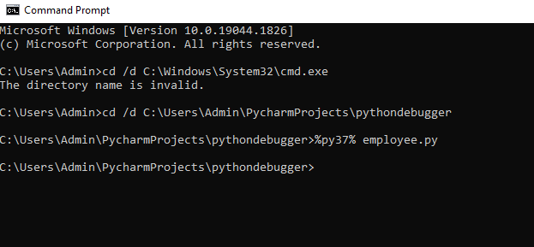
Change directory where file is located and %py% employee.py

Problems tab
when running in console, “problem” tab shows following status
- Error
- Warning
- Weak Warning
- Typo

Connecting line

Raising errors in Pycharm
There are many built in exceptions in python which can be used in code for efficient debugging
Python Documentation - https://docs.python.org/3/library/exceptions.html
Normally used error types are
- KeyError()
- TypeError()
- RuntimeError()
- FileNotFoundError
- ValueError()
- NameError()
- NotImplementedError()

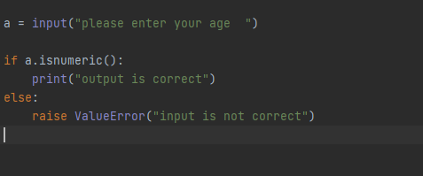

Code execution in Pycharm
Code can be executed in Pycharm in 3 ways
- Console
- terminal – similar to windows terminal
- debug/run mode

If you want to execute various run modes then create separate consoles in same Pycharm instance since all work on same code. If different codes then separate Pycharm instances.

line by line execution, custom shortcut F9, can be changed , go to settings ---keymap –type execution—right click and add keyboard shortcut

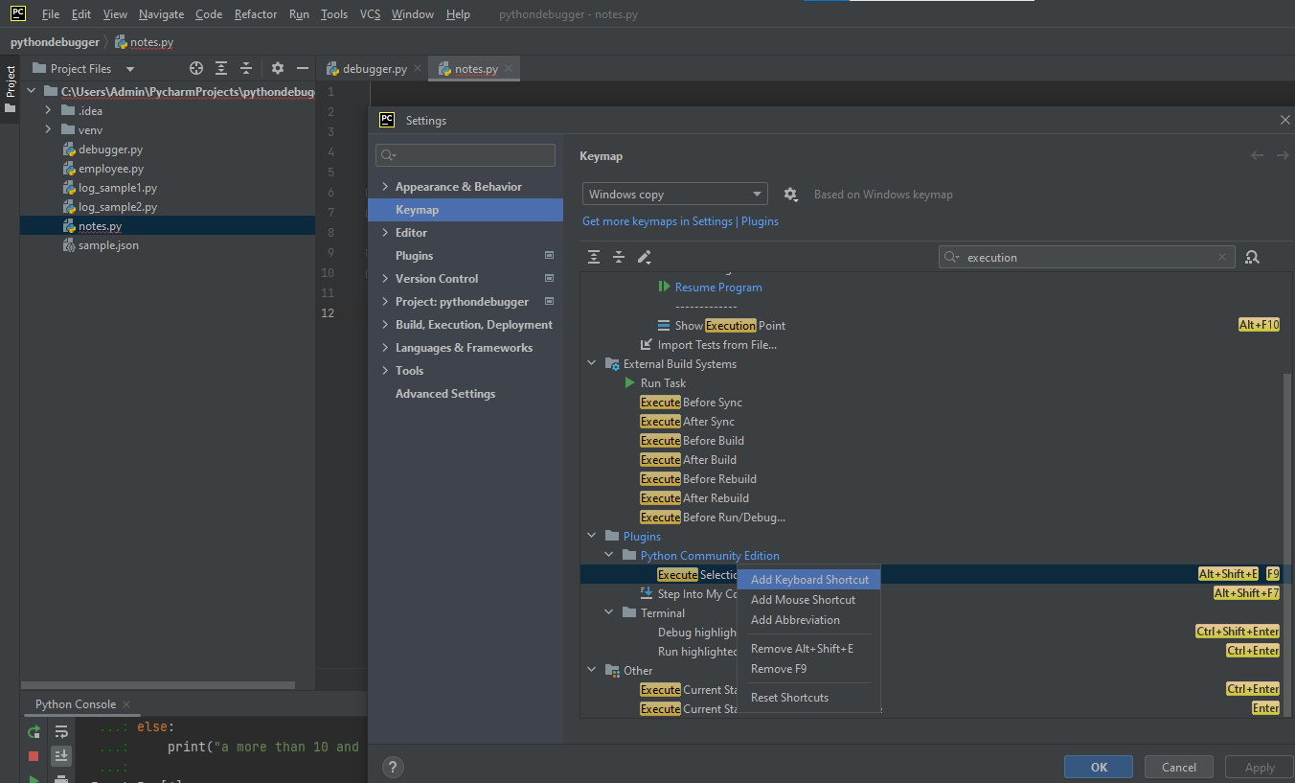

Useful tips

- Always make deep copy of dataframe because shallow copy will make changes in both original and copied dataframes
A (original)------ >B(copied)
If we make changes in A , then it will make changes in B & vice versa

- For loops, my_dict and if-else statements --- > whole code should be selected for execution otherwise, it will throw error (in case of line by line execution)

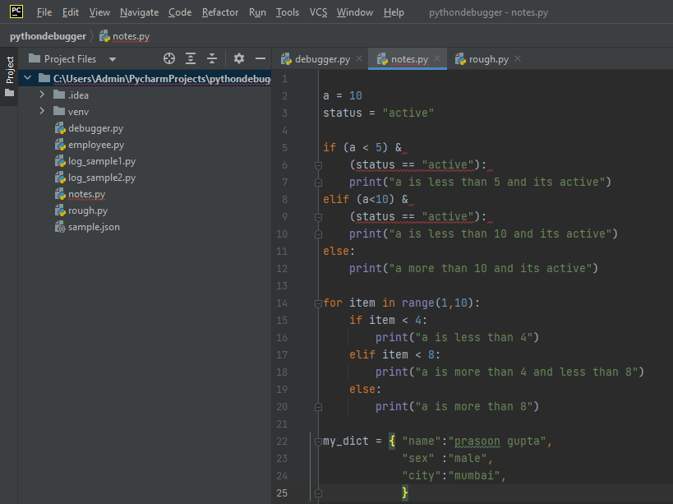

- If panda dataframe column name – “FX ccy pair” then this would be calles df[“FX ccy pair”] >>> such values are stored in csv file in same format
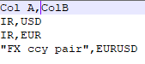
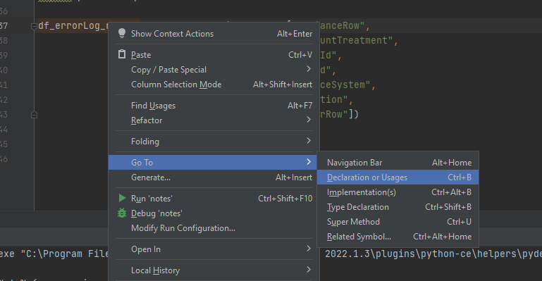
- To see variables declaration or usage, use following mechanism

- If you make changes in code, this will not impact already running code – sometimes, we open new console and make changes in code.
- When you define a function, it should be done in following manner for easy readability and code understanding And right click on it -- go to – Implementation to see its definition
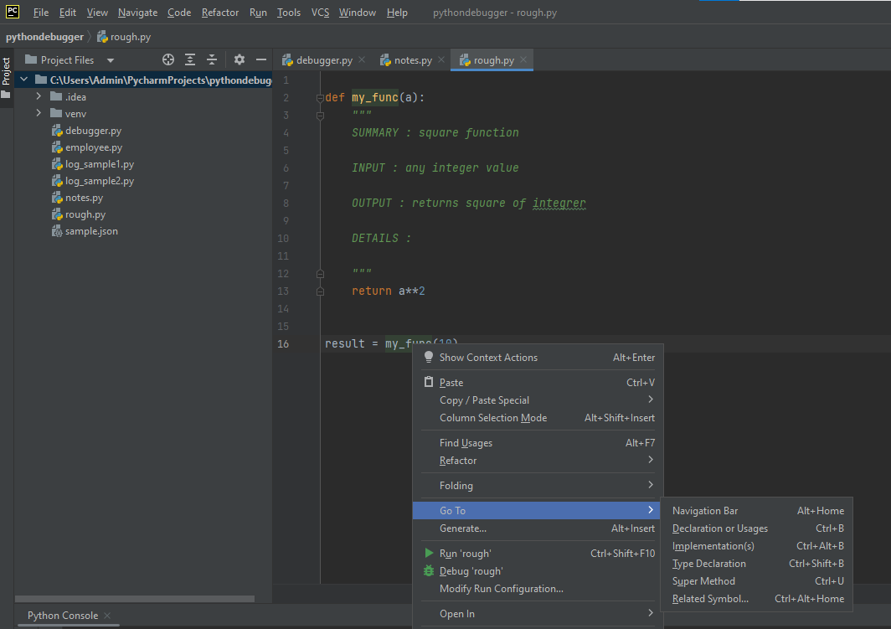

- To remove vertical line from editor pane, uncheck ‘show hard wrap…’
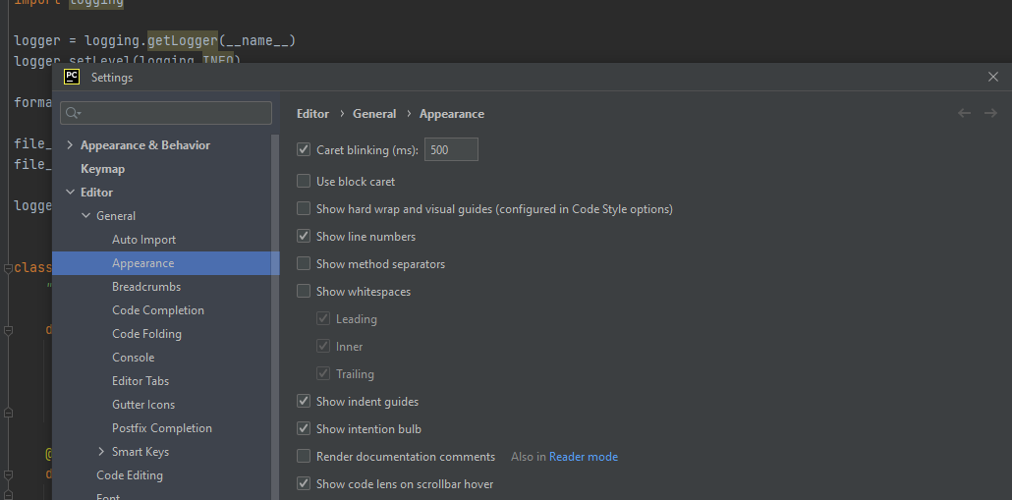

- Use Auto fill with tab
- Hover over the function to see its arguments and help.
- Always use double quotes for strings instead of single quote

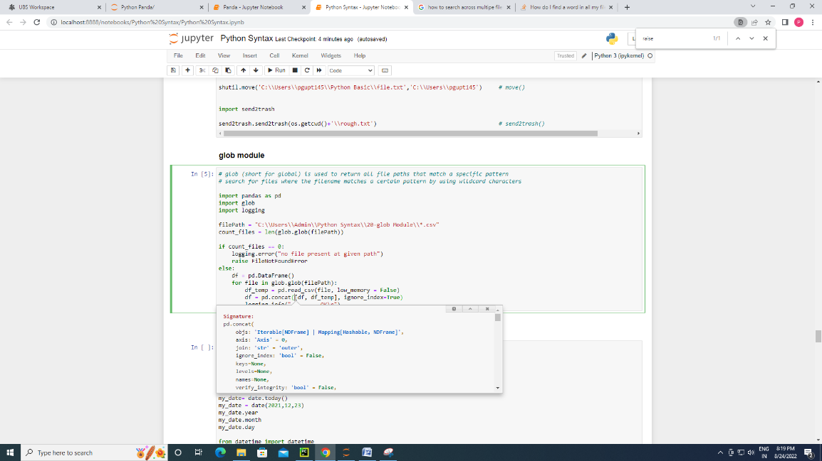
- you can take help from Jupyter notebook for function signature help

- If blinking error in Pycharm then press insert key

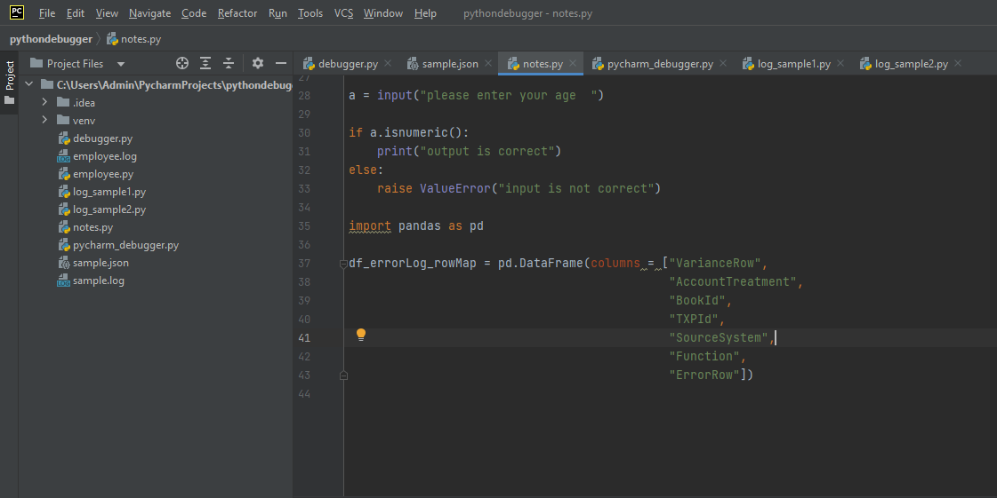
- Multiple lines can be coded for same object in Pycharm

- To copy dataframe to excel df.to_clipboard() in console so it will copy the dataframe which can be pasted in excel
- a backslash at the end of a line tells python to extend the current logical line over across to next physical line
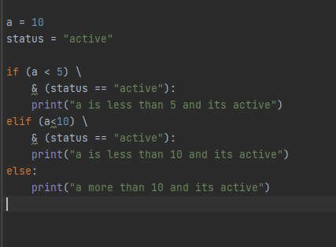

Making Pycharm faster
- in my case, the problem was a folder in my project structure containing 300K+ files totaling 11GB. After moving this folder out of project structure, slowness disappeared.
- Use numpy array more often compared to Panda series or list. Numpy operations are much faster.
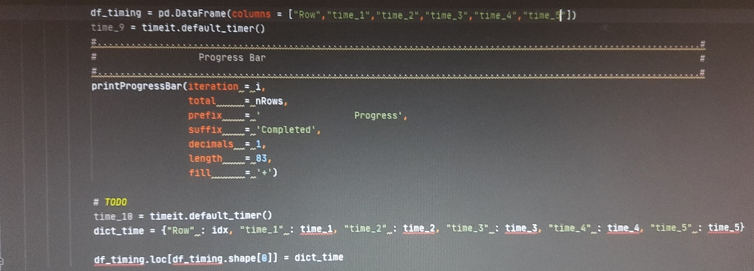
- use timeit module and default_timer function(), put this at various places to see execution time of blocks, this will help to identify which block is causing slowness in code.

- Prod like codes avoid apply/merge/groupby and use for loops. For loops, avoid lookups which make process slow. Dataframe lookups work very slow, use hash table
- Hash tables are a type of data structure in which the address or the index value of the data element is generated from a hash function. That makes accessing the data faster as the index value behaves as a key for the data value. In other words Hash table stores key-value pairs but the key is generated through a hashing function.
- So the search and insertion function of a data element becomes much faster as the key values themselves become the index of the array which stores the data.
- In Python, the Dictionary data types represent the implementation of hash tables. The Keys in the dictionary satisfy the following requirements.
- Search in dictionary is O(1) means if id time taken for row = x and time taken by N rows = N*x

Multiprocessing
- MultiProcessing – 1 CPU – 4 Core – 8 threads
CPU – Central Processing Unit
Core – inside your CPU, you can have more than 1 operation unit called core(Dual Core, Quad-Core etc.)
Logical processor = cores * no of threads handled by core
Normally each core can handle 2 threads so 4*2 = 8 threads so 8 logical processors and this is called hyperthreading

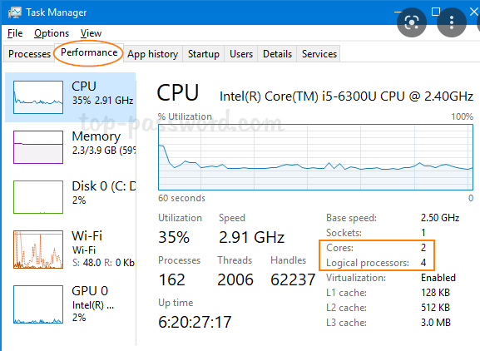

Manu bar

Variable Explorer
Status bar
Console

Different Python interpreter
- System interpreter is one that comes with your python installation. You can use it solely for all python projects or take it as a base interpreter for python virtual environments.

https://stackoverflow.com/questions/51978816/what-is-the-difference-between-pycharm-virtual-environment-and-anaconda-environm

I have to clarify that anaconda is just a collection. The real environment manager is conda. Here is miniconda. It just contains the necessary parts to manage the environment instead of a full anaconda collection.
conda is beyond a simple Python packages manager but is a system-wide package manager. It will help you to install packages without pain. A classic example is installing numpy on Windows. Without conda, it is really difficult as it needs a specific C compiler which is difficult to obtain. But with conda, you can install numpy with just one command conda install numpy. It will automatically solve compiler problem and C dependencies.

So back to your question, when you create an env in Pycharm, it will ask you which env do you want to create: Virtualenv Environment, Conda Environment, or Pipenv Environment. As for me, I usually choose Pipenv Environment as this env will be bound to the current project and can generate a lock file.
In this case, I think you can understand it now: There isn't an env named "created by PyCharm" or "Anaconda". There are only envs named "created by Virtualenv, Conda or Pipenv". And Pycharm just uses and wraps one of them.

So what is the difference between Conda Environment and Virtualenv Environment(Pipenv Environment essentially is a Virtualenv Environment with sophisticated pip)? The difference comes from their different purposes.
Conda Environment is usually for "Python user". They use Python as a tool to do some other works such as web crawling, data mining, and image processing. They don't know much about Python(as they don't need to know) so conda is as automatical as possible. And their tasks can be anywhere in the computer so the envs created by conda are located in user-wide directories. And they sometimes need different Python versions, this can be done in conda but not virtualenv.
Virtualenv Environment is usually for "Python developer". They use Python to build applications or packages. The envs created by Virtualenv are usually located in the current project's directory. So you can create an env for every application and manage dependencies easily.
To sum up:
Conda Environment:
- Manage not only Python packages but also different Python versions and system-wide dependencies.
- Envs are located in user-wide directories.
- Fewer envs.

Virtualenv Environment:
- Manage Python packages. The main purpose is to separate dependencies for every application.
- Envs are usually located in project-wide directories. (Although pipenv creates env in user-wide directories by default,
- many people think in project directories should be the default.) Much more envs.(A new env for every application)
For me, I use both of them. I use conda to manage different Python versions and use pipenv to manage dependencies for my applications.

Difference between pipenv and virtualenv
https://medium.com/@krishnaregmi/pipenv-vs-virtualenv-vs-conda-environment-3dde3f6869ed

Shortcuts in Pycharm
All the shortcuts can be found (cheatsheet) – Help ---Keymap References
Alt +Shift + C – to see recent changes in the script
Ctrl + D – to duplicate lines
Windows + Shift + S – to take screenshot
Ctrl +Home – beginning
Ctrl +End – end
Ctrl + r – Replace
Ctrl + l – to clear terminal in Pycharm
Cls – to clear cmd
Ctrl +’/’ – comment/uncomment
Ctrl +Shift + (+) – to expand all functions
Ctrl +Shift + (-) – to collapse all functions
Tab – indent right
Shift + tab – indent left

Jupyter Notebook Tutorial

- open cmd and type then this will execute the abc script. make sure you are in same directory of abc script
- open cmd and type <pylint abc.py -r y> and this will show code quality.
- to open jupyter notebook, you can open cmd and type < jupyter notebook> and this will open notebook.
- if you want to install any package, type 'pip install package_name' in anaconda prompt. before that you can try conda install package_name (basically it will install that package from anaconda repository and can avoid technical issues)
- if you want to know version of installed package, type 'conda list' in anaconda prompt.
- to update anaconda, type 'conda update anaconda' in anaconda prompt
- want to update any version of package then 'conda update pandas' in anaconda prompt
- There is no main() function concept in python. When we run a script, all the lines with indentation level 0 are executed.
- Script can be run in two ways – directly and indirectly (importing in in another script i.e. even if you are importing a script it is executed)
- When a script is executed directly (not being imported) means its the main script then Python in background assign built-in variable __name__ = ‘__main__’
- Indentation is very important in Python - tab for right and shift+tab for left indentation

